GULISTAN & TURGUT OZAL EDUCATIONAL INSTITUTIONS
INFORMATICS LESSON PLAN

DATE :
DURATION : | 40 minutes
GRADE LEVEL: | 10th Class
SUBJECT : | Creating Worksheet Charts 3
OBJECTIVES : | To learn how to use Excel Chart

LESSON PLAN
Key words:
Materials used: | Microsoft Excel 2003 Book, Computer
Warm-up questions:

Introduction and explanation of the lesson;
CHART TOOLBAR
The Chart Toolbar provides quick access to commonly used actions. When you put your mouse pointer over an icon, it is highlighted in blue and a descriptive tool tip appears. Position your mouse pointer over the icon you want and click on the icon.
To display the chart toolbar choose View>Toolbars>Chart from the main menu.

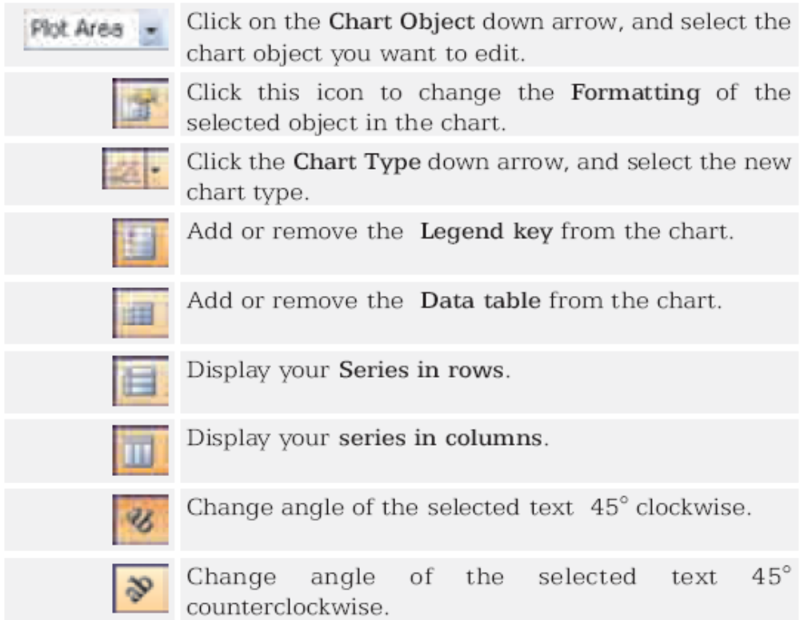

CONCLUSION:

HOMEWORK:

Teacher Director

